TRANSMISSION LINES & WAVEGUIDES – ECA1501
EXPERIMENT – 3

Designing a Quarter wave transformer by varying following Parameters a) frequency b) input impedance c) characteristic impedance

Name | Noorbasha Chotu | Reg. No. | 192412383
Date | 14/10/2027 | Experiment No. | 3

AIM
To design a quarter-wave transformer for an input impedance (Zin) of 50 ohms and a load impedance (ZL) of 100 ohms and to analyze the transformer's performance as the operating frequency is varied across {100 MHz, 200 MHz, 300 MHz, 500 MHz }.ZL =Zo.

SOFTWAREREQUIRED:
SCILABVersion6.1.1

PROCEDURE:
- Open SCILAB software
- Open file-new
- Put the input values
- Type the program
- Execute the program
- End the program

PROGRAM:

clear;clc; Zr=100;s=9;d=0.1; Zs=50;
Ro=sqrt(Zs*Zr);f=500*(10^6);r=d/2; Zof=276*log10(s/r);
Zoq=sqrt(Zr*Zof); L=300/(f*(10^-6));
printf("length of lambda/4 transformer = %f meters\n",L);
printf("characteristic impedance of quarter wave line = %f ",fix(Ro*10000)/10000);

TEST CASE 1
Design a quarter-wave transformer for an input impedance (Zin) of 50 ohms and a load impedance (ZL) of 100 ohms. Analyze the transformer's performance as the operating frequency is varied across {100 MHz, 200 MHz, 300 MHz, 500 MHz}.

OUTPUT TABLE 1
ZR=100 ohms Zin =50 ohms

ZS ohms | ZR ohms | Ro ohms
50 | 100 | 70.71

ZR=100 ohms Zin =50 ohms

Frequency (MHz) | Length of λ/4 transformer (meters)
100 | 0.7500
200 | 0.3750
300 | 0.2500
500 | 0.1500

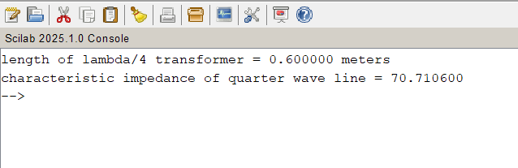

RESULT:
A quarter-wave transformer for an input impedance (Zin) of 50 ohms and a load impedance (ZL) of 100 ohms is designed and the transformer's performance analyzed for the varying operating frequency is varied across {100 MHz, 200 MHz, 300 MHz, 500 MHz }.

\

TEST CASE 2
To design a quarter-wave transformer a ftixed operating frequency of 2 GHz and a load impedance (ZL) of 100 ohms and evaluate its performance as the input impedance (Zin) varied .To validate that the transformer's characteristic impedance (Ztransformer= Ro= sqrt(Zin⋅ZL) changes with Zin.
OUTPUT:
ZR=100 ohms Variable :Zin

Zin | Ro
25 | 50.00
50 | 70.71
75 | 86.60
100 | 100.00
Z_L=100,Omega), (f=2,GHz)

Characteristic Impedance \(R_o\) (Ω) | Input Impedance \(Z_{in}\) (Ω)
50 | 25
70.71 | 50
86.60 | 75
100 | 100

RESULT:
A quarter-wave transformer is designed at a fixed operating frequency of 2 GHz and load impedance (ZL) of 100 ohms and its performance is evaluated for various input impedance values. The variation of transformer’s characteristic impedance with Zin is also validated..

